[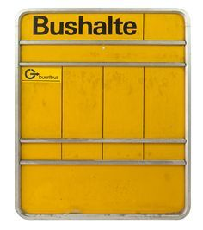](https://www.google.nl/url?sa=i&url=https%3A%2F%2Fwww.pinterest.co.uk%2Fpin%2F527273068870382721%2F&psig=AOvVaw3YFu8Vh4YljfbIrnzgiA5N&ust=1585931734410000&source=images&cd=vfe&ved=0CAIQjRxqFwoTCPiXmKGWyugCFQAAAAAdAAAAABAO)